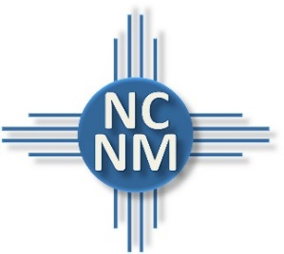
NORTH CENTRAL NEW MEXICO
ECONOMIC DEVELOPMENT DISTRICT

Participating Loan Fund Program

Purpose
NCNMEDD’s Participating Loan Fund partners with Northern New Mexico banks to provide participation loans to help businesses access the capital needed to start and grow. Initially developed in 1985 as a gap financing program, the Fund has lent almost $3.5 million to 49 firms on projects that have generated $15 million in business activity and over 1,000 jobs in the region from an initial $500,000 EDA grant award and $166,667 in local match funding.

Potential Uses & Eligibility
Participating Loans can be used for working capital, inventory, equipment, land and building purchases. Legal businesses located in Santa Fe, Rio Arriba, Los Alamos, Taos, San Miguel, Mora and Colfax counties that are current with all federal loans and federally assisted financing are eligible for a Participating Loan.

Loan Terms & Structure
Loan Amount | NCNMEDD prefers a participation amount between $15,000 and $100,000, making this program ideal for projects between $50,000 and $1,000,000.
Leverage Ratio & Participation Rate | The loan amount from the senior lender must be at least double the amount of the participation loan.
Minimum Interest Rate | A minimum of 4% or 75 percent of the Wall Street Journal Prime Rate (whichever is lower).
Job Creation | At least one full time job must be created per $25,000 borrowed.
Collateral | NCNMEDD prefers a prorated share in the Senior Lender’s negotiated collateral.
Term | The loan term corresponds with the senior loan term and depends on the type of loan requested, generally between 3 and 10 years.
How to Apply
Prospective borrowers can apply to the fund with a letter of introduction from a senior lender partner requesting a participation loan to fill a project financing gap.

Lending Partner Benefits
By partnering with NCNMEDD, senior lenders can reduce their risk levels, increase profits on marginal loans, leverage NCNMEDD as a loan officer, earn a .25% servicer fee, and the loans are CRA credit eligible.
Contact
For more information about the Participation Loan Revolving Loan Fund or for other questions about the program or application process, please contact Alison Turner, NCNMEDD’s Economic Development Planner at (505) 716-5580 or alisont@ncnmedd.com.

